**Photography Service Agreement**

**Hospital Information**

Name: Click here to enter hospital name.

Address: Click here to enter the hospital’s address.

**Photographer Information**

Name: Click here to enter the photographer’s name.

Address: Click here to enter the photographer’s name.

**VetNetwork**, hereafter referred to as Client, enters into the following agreement with the photographer listed above, hereafter referred to as Photographer. The agreement constitutes the entire agreement between both parties and applies to all future transactions.

**A. Copyright, Licenses and Privileges   
Except as otherwise specifically provided in writing and signed by both parties, all Photographs** remain the property of the Photographer.

The Client (VetNetwork) has unlimited usage rights to all photos taken by Photographer. The Client also has rights to crop or alter these photos however the Client sees fit.

Photographer hereby releases and discharges Client, its employees, agents, licensees, successors and assignees from any and all claims, demands or causes of actions that it may have or may from now on for libel, defamation, infringement of copyright or trademark, or violation of any other right arising out of or relating to any utilization of the rights granted under this agreement.

All rights, licenses and privileges herein granted to Client are irrevocable and not subject to rescission, restraint or injunction under any circumstances.

**B. Payment Terms**Payment is to be arranged between the photographer and the veterinary hospital where the photos are taken. Payment should be delivered at the time of the shoot or at a designated time agreed on by both parties.

This agreement contains the entire understanding of the parties relating to the subject matter, and this agreement cannot be changed except by written agreement executed by both parties.

Agreed and Signed:

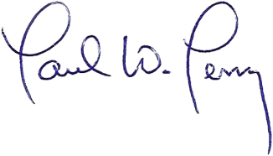

_____________________________ ________________________________

Representative Photographer

VetNetwork, LLC

Date: 1/24/17 Date___________________________